# Visualization Project Proposal

Name: Kunal Kolhe

Group of 1

112748535

## Dataset:

The united states have an obesity problem, which is caused by consuming excessive calories. I will be looking at Sugar and Sweeteners Yearbook Tables published by the United States Department of Agriculture and research whether a correlation can be found between obesity and consumption of sweeteners. If possible, try to find a correlation by state. Otherwise, I will find the relationship between these events in the country.

The datasets I am choosing for this project are going to be accessed from the following databases:

* Sugar and Sweeteners Yearbook Tables published by the United States Department of Agriculture:

<https://www.ers.usda.gov/data-products/sugar-and-sweeteners-yearbook-tables.aspx>

* The Overweight and Obesity Data, Trends and Maps published by the Centre for Disease Control and Prevention of the United States.

<https://www.cdc.gov/obesity/data/databases.html>

During the course of the project, I will be using the various tools I have learned over the duration of the course.

The data processing and the back end will be built using Flask.

The styling of the project will be done using Bootstrap and CSS.

The graphs, charts and the maps will be made using D3.js.

## Approach:

There are many datasets published under each category. The task is to compile the data which will be useful for this task and then perform analysis and then visualize the results.

I will start by finding total usage of caloric sweeteners. This can be divided into corn sweetener, beet sugars, maple syrup, and cane sugar.

I will first analyze how the sugar consumption for the entire country is divided into sub-categories. Then this can be represented in terms of barcharts and pie charts so that data from multiple tables is present in an easily digestible format. All this data will have to be linked manually and combined so that all data can be linked by a key of data which will help to form joins between tables.

<https://www.ers.usda.gov/data-products/sugar-and-sweeteners-yearbook-tables/sugar-and-sweeteners-yearbook-tables/#U.S.%20Imports%20of%20Sugar%20Syrups>

This website has most of the data to form a comprehensive view of the subject.

Firstly, I can compile the production by state and make a graph of production by state.

Second, I can make a graph of the per capita consumption of various forms of caloric sweeteners. This will show a breakdown of the various caloric sweeteners people are consuming.

Third, after plotting a general trend of consumption of caloric sweeteners over the years, I will take data from the CDC overweight and obesity website and plot the trends and see whether there is a correlation between these 2 data.

Different plots:

I will be making use of various plots from d3.js to make this dataset extremely intuitive.

I plan to use the following:

* USA Map chart
* Bar Charts
* Pie Charts
* Graphs

The main contribution of this project is to make visualizing this page much easier. I have not found a dataset of obesity per state and hopefully I do, but this is already a huge task.

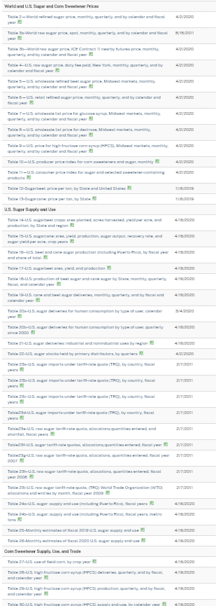

As you can see, this website provides datasets which are very comprehensive but they are extremely unintuitive. There are millions of datasets like these in the world, but almost all of them are just that datasets. Only people with the knowledge and skills to work with the data can understand the data.

There is a negative connotation to data collection these days, but I believe that data collection is a huge contributor towards mankind’s step towards the future. Through this project, I aim to make this dataset accessible and show the importance of data collection.

If I can link the caloric sweetener consumption of obesity, that is an example of how data can be used to plan future actions and help decide legislation.